Accepted Short Piece for Current British Work section of the Oral History Journal
Under an Artificial Sun
Debbie Ballin is a researcher, filmmaker and writer based at Leeds Arts University and has just commenced work on a new multi-disciplinary oral history project funded through a Wellcome Trust Research Bursary. The project runs from Sept 2018 - March 2019 and the research will be written up as a multi-disciplinary arts project.

‘Oh yeah, I would have been a coal miner, I would think, if I hadn’t had tuberculosis when I was 12.’ Tom Jones, Singer-Songwriter

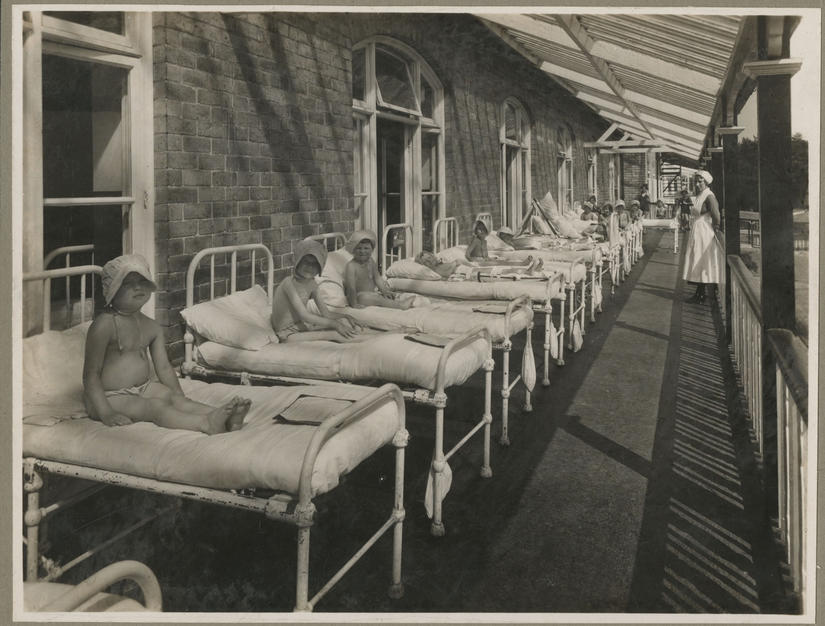

Under an Artificial Sun focuses on materials in the Stannington Children’s Sanatorium collection held at Northumberland Archives. This collection contains a wealth of material including: patients medical records and reports, radiographs, educational logbooks from the Sanatorium School from 1906 – 1970, a Matron’s Day Book from 1906 – 1933, photographs, ephemera and a collection of twenty-six oral history interviews with former patients recorded in 2013. The project is a collaboration between Leeds Arts University researcher, writer and filmmaker Debbie Ballin and Dr Janice Haigh, Senior Lecturer in Childhood Studies at Sheffield Hallam University.
Many of the children hospitalised at Stannington Sanatorium with tuberculosis were from working-class backgrounds and had been living in extreme poverty. In addition to medical treatment, hospitalisation included a multitude of emotional and developmental experiences. Under an Artificial Sun investigates connections between this historical material and contemporary debates around attachment, resilience, creativity, boredom and institutionalisation within childhood studies. It seeks to uncover stories of the emotional legacy of hospitalisation; examine experiences these children may not otherwise have been exposed to and to explore how hospitalisation may have shaped their lives in unexpected or seldom-discussed ways.
The medical and social aspects of hospitalisation at Stannington Children’s Sanatorium are well documented. The research builds on this body of work to create a more textured understanding of the experience of major illness in childhood and the way it shapes us as adults. The research informs the development of a new multi-disciplinary work that will weave together new and existing oral history testimony, writing and archival material. Practice-based methodologies will be utilised to tell detailed and layered stories about hospitalisation in childhood to enrich our understanding of this experience.
The project is supported by a Wellcome Trust Research Bursary Award, Northumberland Archives and Leeds Arts University.

