Transcendental Housework – By Paula Chambers

My mother was not a feminist, yet growing up in 1970s suburban north London I was witness to, and complicit in, my mother’s active refusal to conform to the expectations of a good housewife. Cleaning, tidying, dusting, washing up, were all low on the list of my mother’s priorities, instead she played tennis, she grew vegetables, she went out dancing; my sister and I were left to our own devices.

As a feminist artist and a mother, I have adopted my mother’s domestic dissent, integrating it as philosophy into the processes and outcomes of my art making practice. I do not have a studio but make art in my kitchen; I rarely clean or tidy up, but instead utilize my domestic space and the objects that inhabit it, as a temporalized site of domestic resistance.

This paper is a brief representation of how I have materialized my ongoing relationship with my mother. The sculptural objects that I discuss here can be read as an iconography of the domestic sphere; in particular, the ambivalent understanding I had as a child of my mother in her role as a mother. I re-enact the domestic unease of my childhood, projecting maternal dissent on to the haunted objects that formed my sense of self in the world. I subvert meaning and ideologies through affective interrogation of subservient domestic objects; coffee tables, footstools, and ornaments.

To understand this ambivalence I have towards my childhood experiences of mothering, it is useful to turn to Jessica Benjamin’s theories of maternal intersubjectivities in which she repositions relationality as key to the formation of subjectivities. According to Benjamin, an infant has the ability to, and the intention to, differentiate and relate to the outside world from birth, and there is always an active responsive interaction going on between the infant and her parents and other adults.

If the Freudian model positions the relationship between infant and caregiver as based on the satisfaction of basic needs, the caregiver as a consequence being objectified, the intersubjective model focuses more on the social element of this relationship. So rather than the individual sense of self developing as purely autonomous and independent, relying on a symbolic separation, intersubjectivity reinforces the growth of self in relation with the caregiver, in this case, the mother.

Maternal intersubjectivities are about how infants relate to and recognize others, how they seek out and actively engage in this relationship. By recognizing the other as also being a subject in his or her own right, someone different yet alike, capable of sharing similar physical and psychical experiences, there develops mutual recognition between self and other, a space to experience sameness without obliterating difference.

If we also understand maternal intersubjectivities to encompass not only the relationship between mother and infant, but to be an ongoing and mutually adaptive relational experience, then we might ask, how is this intersubjectivity envisioned and articulated. As a little girl growing up in 1970s Britain I recognized in my mother a casual disregard for social convention and understood myself to be an active component in this. Yet I also recognized that this lack of domestic niceties caused discomfort and unease in others, and as such felt resentful towards my mother for our seeming collusion.

Puberty and young womanhood accentuated this resent, yet also a growing admiration as my mother’s apolitical refusal to play the role of housewife became newly politicised in Britain following the social gains of the Women’s Liberation Movement. The intersubjective relationship I had with my mother became one of ambivalence, for whilst I sought to gain an independent subjectivity, I was still bound by the dominant discourse of the male subject who operates in the public sphere, but who is maintained in the private sphere by women. This is not a neutral system, but one based in inequality where the only position open to women was the abstract opportunity to become men.

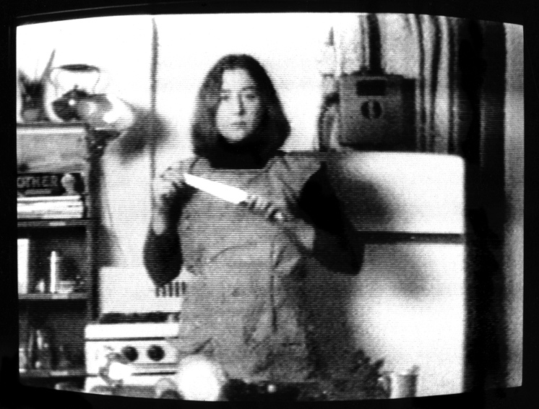
Feminist artists of this time made artwork that highlighted women’s anger and frustration towards the feminization of domestic drudgery. The personal became political, and Martha Rosler was angry in the kitchen. The short film, ‘Semiotics of the Kitchen’ humorously critiques the mass media image of the smiling, middle class, white housewife.
Martha Rosler, “Semiotics of the Kitchen

Mierle Laderman Ukeles repositioned housework and domestic care giving as maintenance acts, and aligned these through performance to the unseen work of cleaners, janitors, sanitation workers and others in the maintenance industry. In her maintenance manifesto, Ukeles insists that the ideals of modernity (progress, change, individualization) are dependent on the repetitive and boring labour of maintenance (cooking, cleaning, child rearing), and importantly, that this labour is not soley confined to the domestic sphere.

In Britain Mary Kelly with Berwick Street Film Collective, made the short documentary film ‘Night Cleaners’, about the campaign to unionise the women who cleaned office blocks at night and who were being victimised and underpaid by their employers. Informed by Marxist and feminist critique, projects such as these were informed by the understanding that unpaid and underpaid maintenance labour could be thought of as equivalent to other forms of oppression. (Molesworth, pg 80) And Alexis Hunter undertook a series of photographic narratives revealing a more individualised resentment towards the domestic sphere.

More recently Diane Borsato enacts this domestic unease in her video installation “Three Performances (After Joseph Beuys, Marina Abramovic and Bonnie Sherk)”. In Joseph Beuys’ performance, “I Like America and America Likes Me”, the artist inhabited the gallery space alongside a wild coyote. The coyote was in fact a domesticated animal, a fact that offers an alternative reading of the performance, the evidence of a shared experience negating any potential danger or threat posed by a truly wild creature.

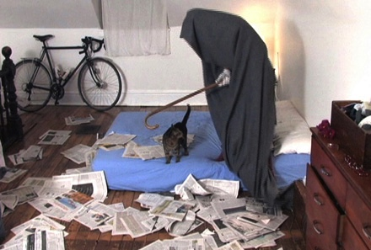
In Abramovich’s performance “Dragonheads”, the artist encountered a more imminent threat in the form of large constricting snakes, and although she looks decidedly uneasy in images of the performance, we understand that this is a set up, and that the artist will not in fact be in any danger of death or strangulation.
Diane Borsato, “Three Performances (after Joseph Beuys, Marina Abramovic and Bonnie Sherk)”

Likewise, Bonnie Sherk’s performance “Public Lunch” where the artist ate lunch in cages with various animals, such as lions and tigers, at the San Francisco Zoo. Although the artist appears to be aligning herself with both the potentially lethal nature of the animals she shared this performance with, and to the confined and domesticated situation women of that time found themselves in, again the threat is negated by steel bars and trained animal handlers.

Undertaking the potentially dangerous acts of the original performances in her New York apartment, her cat playing the part of the wild animals, Borsato subverts traditional systems of performance and presentation without diminishing the value of the original acts. As such the works are given a new critical perspective. These actions remap Borsato’s home and shift the balance of private towards the public. As Anthony Vidler comments in the Architectural Uncanny, “private space is revealed as infinitely public, private rituals become publicized”.

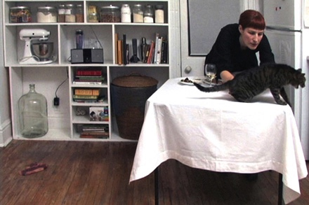
Enacting Sherk’s “Public Lunch” Borsato’s cat was not interested in the steak originally served to the lions and tigers, but as those of us with cats know, was much keener to share Borsato’s own cooked and processed lunch. Enacting Beuys’ “I Like America”, the potential threat of a wild coyote becomes laughable when the original animal is replaced with a domestic pet cat.

The modernist understanding of domestic space as private and aligned to femininity is reimagined in this work by Borsato. She seriously, and rather humorously, brings to our attention how domestic spaces and actions transcend our understanding of the very nature of the activities that take place within these spaces. Is this housework or artwork?

Feminist critiques of the domestic have presented us with the option to view housework as a political site similar to that of artistic work. Both can be seen to remain outside of the social relationship of value-labour, as neither housework nor artwork really produce anything, and therefore can be seen to reject the commodification of human activities. Feminist artists have of course engaged with these concepts historically, as illustrated earlier in the work of Martha Rosler, Mierle Laderman Ukeles, Mary Kelly and Alexis Hunter.

In my own practice I am very much working within this framework of housework as artwork, in the space where the boundaries between art and life become blurred. If the temporalized notion of space can be seen as a schizophrenic condition of presence and remoteness, where activity defines the nature of a space; what then can be made of my utilization of kitchen work surfaces as cutting mats, of how the objects and accouterments of home become the tools and trappings of art practice. What also can be said of the domestic dissent of my own mother who filled the house with the toxic fumes of burning plastic as, commandeering the gas cooker in her kitchen, she melted holes in the bottom of yoghurt pots with a barbeque skewer whilst toast burnt under the grill.

‘Haunt I’, ‘Haunt II’, and ‘Tilt’, are a series of dysfunctional coffee tables I have made. Each tabletop holds ghostly images of girls, horses and apocalyptic landscapes, each slants alarmingly, the legs of the tables had been tampered with.
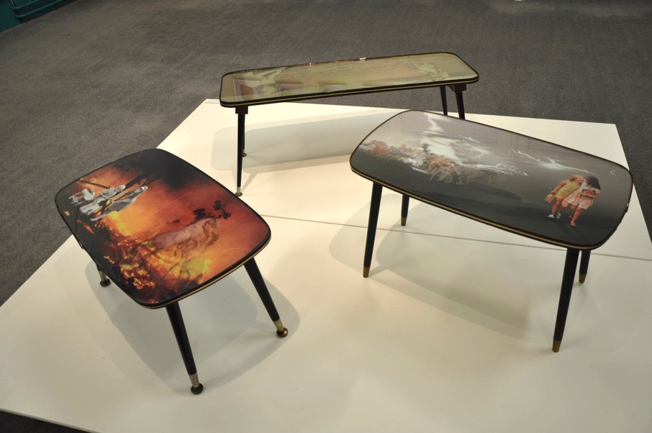
Paula Chambers, “Haunt I”, “Haunt II” and “Tilt”

Recently I gained possession of the original coffee table my mother received as a wedding present. Although I now use this table as my living room workstation, my childhood memories of this object are more disruptive. My sister and I used it as a fort when we played cowboys and Indians, we removed the legs and used it as a slide, we camped out under it. As a teenager I once left a cigarette burning on it, a scar the coffee table still bares. My mother hardly noticed.

The coffee table, or occasional table as it was popularly known before modernist design upgraded it as a high-end desirable object, is an unselfconscious object. It is over-looked and seemingly trivial in itself, and therefore can be distanced from issues of taste and aesthetics. It is perhaps an object more suited to study within the field of material culture rather than that of modernist design. In the everyday practice of modernity it is these non-conforming and popular objects that offer a space for a more inclusive analysis of culture, a process that Judy Attfield describes as feral design history.

I like these overlooked objects, their materiality speaks to me of the psychic significance of the stuff of home. The appropriation and disruption of these seemingly trivial objects as an intentional politicized creative act can be seen as a transference of the dominant understanding of the primacy of the body, on to the objects and matter that frame and structure women’s domestic lives. They become a transformation of the mundane and the everyday into the transcendental.

Daniel Miller has written repeatedly of the dualism between immateriality and materiality, of the position material objects hold as vehicles of transcendence, and of material culture’s role as an object based philosophy through which our understanding of ourselves as social beings can be constructed.

Sculpture from everyday or domestic objects has been labelled assemblage, and it is interesting that this term has also been adopted by Jane Bennett and other Object Oriented Philosophers as a way of explaining the vibrancy of matter and of the interrelatedness of subject and object when theorising ideas around objects with agency.

Bennett talks of ‘the call of things’ and analyses the vibrancy of objects in relation to hoarding where individuals experience objects as active agents in their own ability to accumulate. Artists too understand this ability of objects to affect our experience of being in the world, that objects have resonance and agency, and as such, perform both as sculpture and as object. Breaking down the hierarchy between subject and object, it can perhaps be said that relational intersubjectivities also operate between objects and subjects, and that the stuff of home may be as important in the formation of subjectivities as maternal relations.

In constructing myself as a woman, as a mother, as an artist, I find I have turned to the objects that I first encountered as a girl and have reinvented my memories through subtle interventions and processes of making that upset expectations. Deliberately interfering with the materiality of both objects and social constructs, the artwork that I make is, in a sense, reconstructing the relationship I had with my mother as a child, and of how this formed me as a person.

My mother was, and still is, funny and careless, extremely socially skilled, a little self obsessed, and almost pathologically uninterested in anything related to the domestic sphere. Like most of us, it wasn’t until I was much older that I realized the childhood I experienced in my mother’s careless and disinterested hands, was actually one of neglect. There were no rules, my sister and I were never told off, mealtimes were random and the quality of food served unpredictable. Nothing was out of bounds as I long as I took my little sister with me. So we played on the street, in the fields that border the motorway, in the park that had flashers. We stole sweets from the local sweetshop, we took apples from the garden to feed the gypsy ponies tethered on the grass verges of the main road nearby. I have no recollection of there ever being an adult present, I was perhaps 5, my sister 3.

And in the house too, we did as we pleased, my sister and I. We drew on the walls, we broke the Victorian china doll’s tea service that had been my great grandmother’s. We made virtually inedible meals for ourselves, mashed banana with digestive biscuits, cooking apples with a bowl of sugar for dipping. And the coffee table became the central prop for all our indoor games. The coffee table has dansette legs, they unscrew, this offered endless possibilities for transformation. Tipped on its side with a sheet spread on top it became a space for secrets, the addition of cushions and it became an encampment. It was a fort, a castle, a barricade. With 2 legs removed the slippy formica surface provided a mini living room slide, if I positioned this makeshift slide carefully enough I could ensure that my sister hurt herself on the edge of open doors, on the stone clad fire surround, on the cast iron fire horse that was also an ever present prop to our games.

Aged 16 and newly enamored with punk rock, I removed 2 of the legs from the coffee table and used them as giant knitting needles with which to knit myself a large black holey jumper. Begrudgingly, I knitted my sister one too.

As an artist, and a feminist, I have developed a practice that is object based, process based, theoretically informed, and intrinsically domestic. It is only in more recent years that I have recognized the importance of my visual references in relation to my own specific childhood experiences. My spatial memory of the tiny and bizarrely furnished bungalow I inhabited as a girl, the intersubjective encounters that formed my sense of self, (including of course the cheerful neglect that substituted for mothering), a growing awareness of the politicization of women’s relationship to the domestic sphere, and a healthy disregard for social convention, have all informed both the processes and outcomes of the art work I now create.

The domestic objects of my childhood haunt me, the working class aesthetic of popularist modernity has seeped unconsciously into my soul. My references muddied and mixed, and tinged with misplaced nostalgia. And so I made 3 dysfunctional coffee tables.

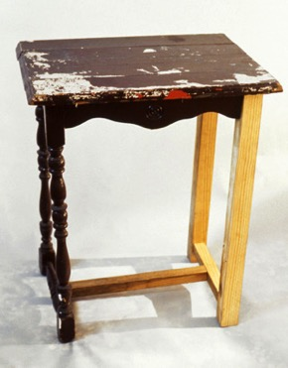
Like Andrea Zittel, who created this little table as part of her series of repair works, I see domestic problems as ones that require solutions, although not perhaps practical solutions. Zittel sees her home as the site of an ongoing performance, she disrupts our relationship with consumer systems through empowerment, inventing new models or roles to fulfill our needs. My dysfunctional coffee tables too disrupt expectations, and are presented as objects that fulfill the need for a specific kind of remembering. They are chaotic encounters of past and present, of personal lived experience and of a feminist understanding of the confining nature of domesticity. They are liminal objects, existing in the inbetween spaces of art and functionality. They are feral objects.
Andrea Zittel, “Untitled Repair Works”

As 21st century feminists we now understand the domestic as a space of potential autonomy and empowerment, that these spaces of femininity offer a site for meaningful acts of minor disruption.

On the sideboard of my childhood home there was a wedding photograph of my parents made into a sculptural object. My sister and I incorporated this strange wedding object into our games; it became quickly soiled.

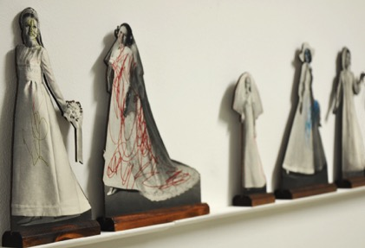
‘Bridie, 21’ is a feminist reinterpretation of this object, a series of images cut from a 1960s wedding magazine, freestanding and backed with plywood, each have been carelessly scribbled on by toddlers in brightly coloured felt tipped pen.
Paula Chambers “Bridie, 21”

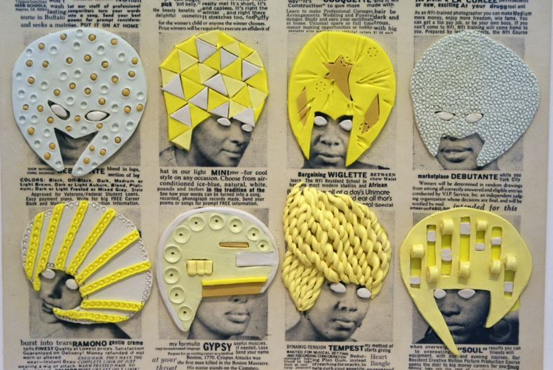
Ellen Gallagher appropriates images from women’s magazines as a form of visual resistance to cultural stereotyping, yet in doing so, simultaneously reminds us of the historical legacy of these images. Gallagher’s “DeLuxe” is a series of pages from old copies of magazines such as Ebony that have been collaged and overlayered with lurid yellow plasticine, in effect liberating the images from their original context, the transformative process confronting unresolved issues of race and gender.
Ellen Gallagher, “DeLuxe”

“Bridie, 21” is intended to bring to the fore the ambivalent relationship women and girls have towards the idea of marriage and domesticity. How the agendas of femininity persist yet also through time has lost their luster, have become tarnished through inspection and re-inspection. The careless hand of a child a symbolic reminder of the potential for disruption.

Ultimately, what these artworks have in common, my own included, is a dissenting voice, an appropriation of the domestic as a methodology for questioning cultural and social assumptions. Through manipulation of the materiality of objects and the subversive occupation of domestic space I have constructed a practice that reimagines my childhood relationship with my mother, and positions our strategies of domestic non-compliance as a process I like to call transcendental housework.

References
Bennett, J. (2009) Vibrant Matter: A Political Ecology of Things. Duke University Press

Molesworth, H. (2000). House Work and Art Work. October. Vol. 92 (Spring, 2000), pp. 71-97

Vidler, A. (1992) The Architectural Uncanny: Essays in the Modern Unhomely. MIT Press

Yu, Y. (2002). Relocating Maternal Subjectivity: Storytelling and Mother-Daughter Voices in Amy Tan’s The Joy Luck Club
http://journals.sfu.ca/thirdspace/index.php/journal/article/viewArticle/yu/49

